CS 6327 Video Analytics Assignment 1

Instructor: Dr. B. Prabhakaran TA: Kanchan Bahirat

Due – February 5th, 2017

Only submission on eLearning is accepted.

**Description:**

Given an image I with various fruits (Fig. 1), please:

1. Create a brightness adjusted image B1 from the image I by adding a constant factor 50.
2. Convert both images from RGB to HSV color space. Write your own code to convert from RGB to HSV color space.
3. Find the “red apple” in each image using both of the following methods and mark the apple with a bounding circle/box . Methods to be used:

* Object detection **based on color** in RGB domain
* Object detection **based on color** in HSV domain

1. Convert the red apple into a green apple and vice versa.

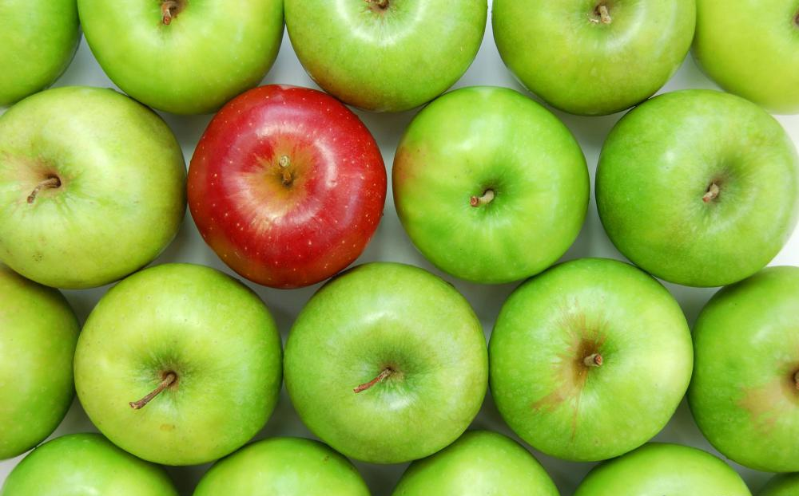

Figure 1: Images with various apples.

**Desired Output:**

Display **all** the intermediate results. For example,

*Birghtness adjusted image:*

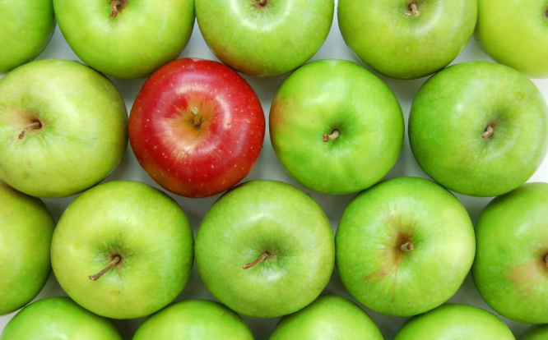 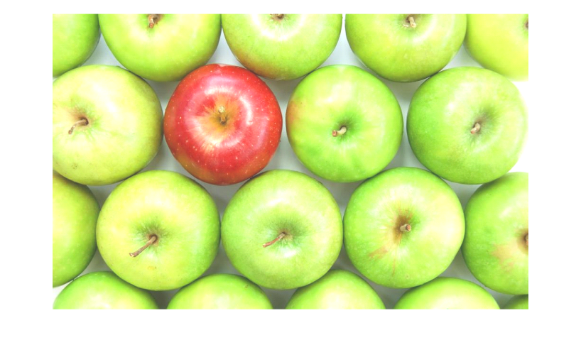

*RGB to HSV conversion:*

 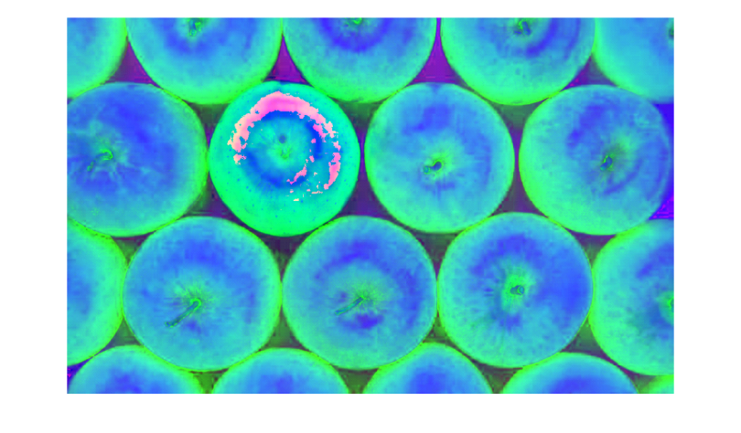

*Object detection based on color in HSV domain: (Show the result for all images)*

 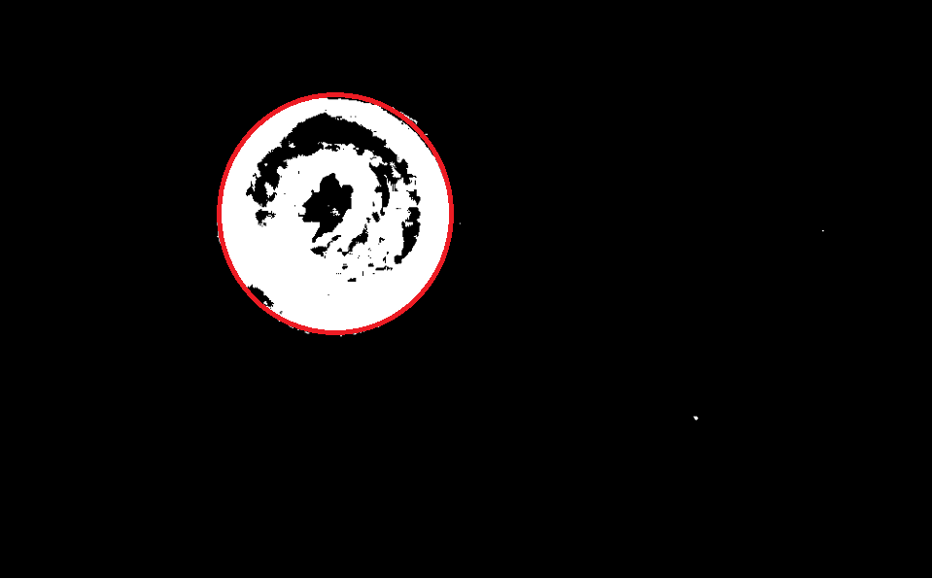

*Turing the red apple to green and vice versa*

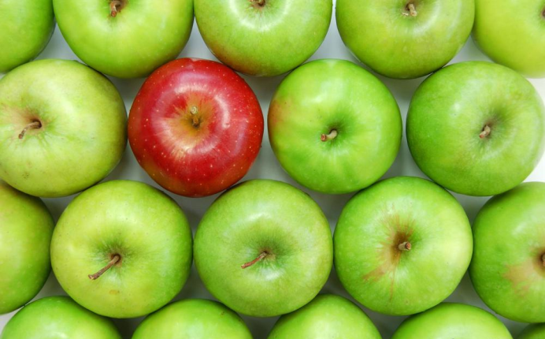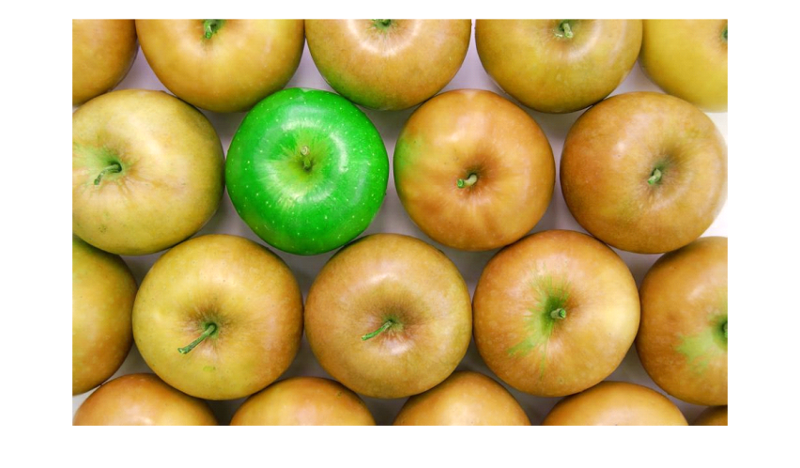

*These are few example of expected output. You need to show* ***all*** *the intermediate results.*

**Where to submit the assignment:** eLearning.

**Late Submissions: Accepted**. However, there will be a penalty when you are late.

**Rubrics:**

Load and Display Images -- 10 points.

Create brightness-adjusted image -- 10 points

Convert to HSV Images -- 20 points

Detect the Red Apple in RGB domain for all images -- 20 points

Detect the Red Apple in HSV domain for all images -- 20 points

Swap Colors -- 20 points

NOTE: **Do not use built-in functions (in OpenCV/Matlab/or other tools)** for step 1 to 4 – operate on each pixel value.